TASK 1 – GUI DESIGN REVIEW Bloom’s Level: K4 – Analyse
Diagnose and Repair a Poor Event-Handling Design
6 Marks
A junior developer has built a student fee-payment window. Every button is handledbythe same listener, and the complete program logic is written inside it.
public class FeeWindow extends Frame implements ActionListener { TextField regNo = new TextField(); TextField amount = new TextField(); Button pay = new Button("Pay"), clear = new Button("Clear"), receipt = newButton("Receipt");
public void actionPerformed(ActionEvent e) {
if (e.getActionCommand() == "Pay") {
double a = Double.parseDouble(amount.getText());
Connection c = DriverManager.getConnection(URL, USER, PWD); c.createStatement().executeUpdate("INSERT INTO fees VALUES('" + regNo.getText()"'," + a + ")");
Thread.sleep(3000); // wait for bank confirmation System.out.println("Paid");
} else { regNo.setText(""); amount.setText(""); }
}
}

+
Task 1.1 – Diagnose the Design | 2 Marks
Identify at least five design deficiencies in this code. Do not focus merely on syntax. Examine aspects such as:
• Separation of interface and logic
• String comparison of the action command
• Handling of invalid or empty input
• Database work performed on the event-dispatch thread and the effect of sleep() on the window
• Feedback to the user
• The Receipt button
• Security of the SQL statement
• Closing of the window and of the database connection
• Checked exceptions that are not handled
For each deficiency, explain briefly what the user would experience or what couldgowrong.
Task 1.2 – Repair the Design | 3 Marks
Redesign the program so that the window only collects input and shows results, andaseparate FeeService class performs validation and payment. Present the class structureand rewrite the event handling.
Task 1.3 – Design Defence | 1 Mark
In not more than 100 words, explain why your redesign is easier to test and maintain. Alternative Concept and Complexity Analysis
If, instead of one listener with an if–else chain on the action command, each button hadits own listener object (or a Swing Action), what would the solution be? Analyse the timeto dispatch an event for k buttons (up to k comparisons versus O(1)) and the space usedby k listener objects.
Evidence Expected
A reasoned diagnosis, a corrected design and a concise justification.
Answer:
1.1:
1. Poor separation of interface and business logic
The actionPerformed() method handles button clicks, payment processing and database operations all together.
- GUI code and payment logic are mixed.
- It becomes difficult to maintain and test the program.
- The payment logic cannot easily be reused in another application.
2. Incorrect String comparison
The code uses:
if (e.getActionCommand() == "Pay")
It uses == to compare strings instead of .equals().
- == compares object references.
- It may fail to compare the actual text correctly.
- The Pay button might not execute the expected operation.
Correct approach:
if ("Pay".equals(e.getActionCommand()))
3. No input validation
The program directly converts the amount using:
double a = Double.parseDouble(amount.getText());
- 
Empty input or alphabetic characters can cause NumberFormatException.
- Negative amounts and zero are not rejected.
- Invalid registration numbers are not checked.
4. Database operations block the GUI
The database connection and SQL execution are performed inside actionPerformed().
- These operations may take time.
- The GUI may freeze while processing the payment.
- The user may think the application has stopped responding.
5. Thread.sleep(3000) freezes the window
The program waits for three seconds using:
Thread.sleep(3000);
- 
The event-dispatch thread is blocked.
- The window may become unresponsive.
- The user cannot interact with the application during the wait.
6. Poor feedback to the user
The program only prints:
System.out.println("Paid");
- 
The confirmation appears in the console rather than the GUI.
- The user does not receive clear payment confirmation.
- There is no proper error message if payment fails.
7. Receipt button does not work correctly
The program uses an else block for every action other than Pay.
else {
regNo.setText("");
amount.setText("");
}
- 
Both Clear and Receipt enter this block.
- Clicking Receipt clears the fields instead of generating a receipt.
- Each button should have its own appropriate event-handling logic.
8. SQL injection and database connection problems
The program builds an SQL statement by directly inserting user input into the query.
- Malicious input could manipulate the SQL statement.
- PreparedStatement should be used to protect against SQL injection.
- The database connection is not properly closed.
- Database exceptions are not handled appropriately.
1.2:

class FeeService {

public String processPayment(String regNo, String amountText) {

if (regNo == null || regNo.trim().isEmpty()) {
throw new IllegalArgumentException(
"Registration number cannot be empty."
);
}

double amount;

try {
amount = Double.parseDouble(amountText);
} catch (NumberFormatException e) {
throw new IllegalArgumentException(
"Please enter a valid amount."
);
}

if (amount <= 0) {
throw new IllegalArgumentException(
"Amount must be greater than zero."
);
}

return "Payment successful!\n"
+ "Registration Number: " + regNo
+ "\nAmount Paid: Rs. " + amount;
}
}

public class Main {

public static void main(String[] args) {

FeeService service = new FeeService();

// Test 1: Valid payment
test(service, "STU101", "2500");

// Test 2: Empty registration number
test(service, "", "2500");

// Test 3: Invalid amount
test(service, "STU102", "abc");

// Test 4: Negative amount
test(service, "STU103", "-500");
}

static void test(
FeeService service, String regNo, String amount) {

System.out.println("\n--------------------");

try {
System.out.println(
service.processPayment(regNo, amount)
);
} catch (IllegalArgumentException e) {
System.out.println("Payment Error: " + e.getMessage());
}
}
}

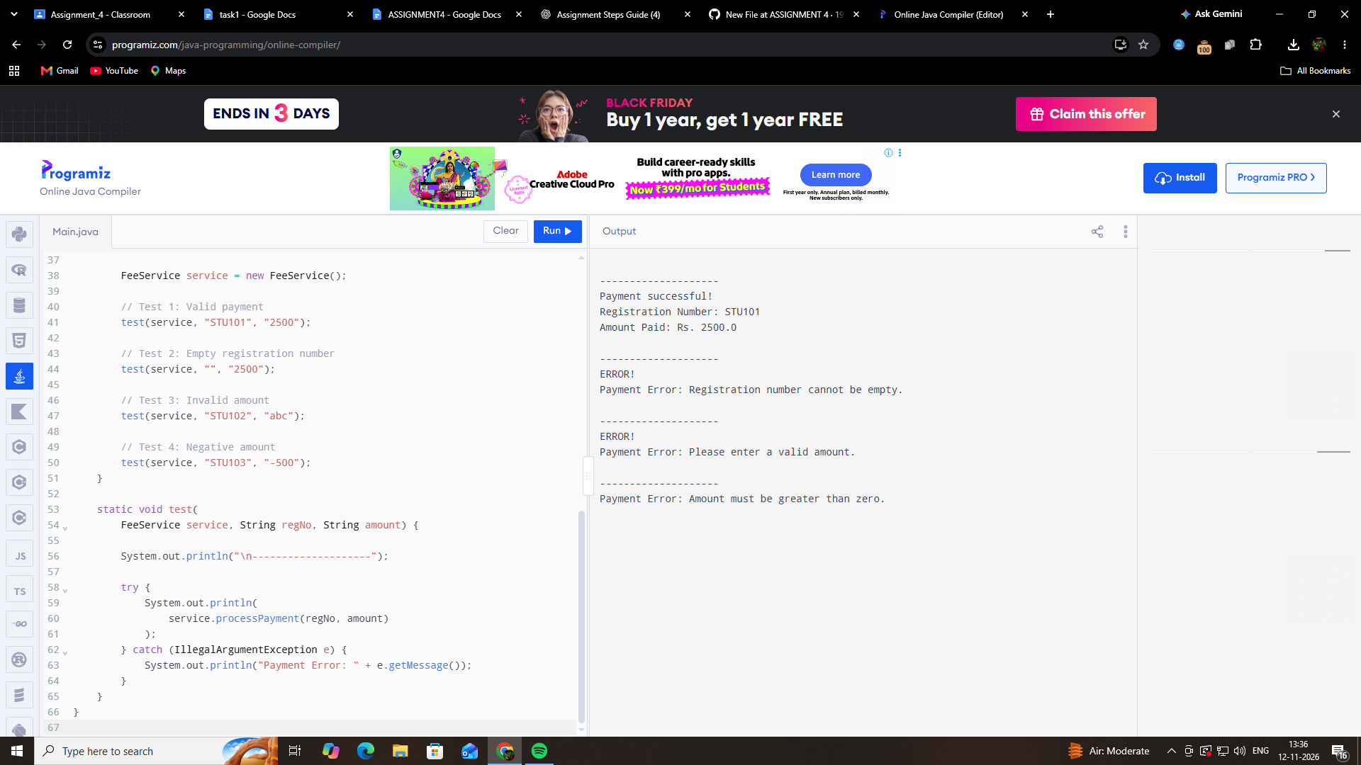

1.3:
The redesigned program separates the GUI and business logic into two classes. The FeeWindow class handles user input and displays results, while the FeeService class performs validation and payment processing. This separation makes the program easier to test because the payment logic can be tested independently without opening the GUI. It also improves maintainability because changes to the interface do not affect the payment logic. Separate event handlers make each button's function easier to understand and modify.

